CET 753
Lab Completion Sheet
Chapter 5

Name __Shannon Palmlund__________________________

# | Page | Chapter/Activity | Status | Description
32 | 187 | 5-1 |  | Encrypting Files

Screen Shot(s) | Documentation
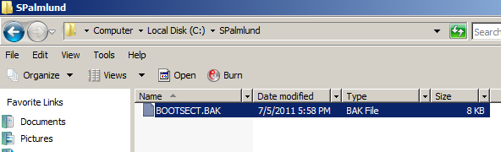  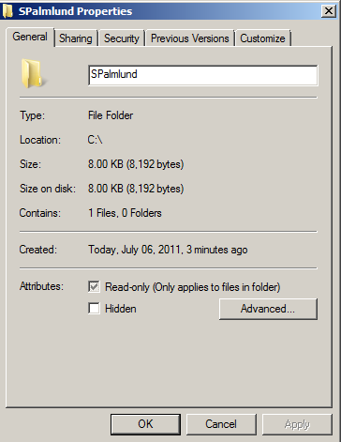  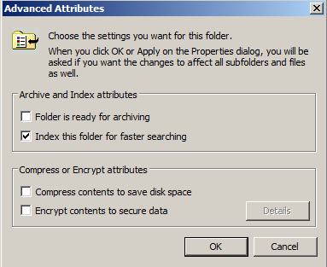 | 1. Sample of copied file in SPalmlund folder under c:  2. I created a folder called SPalmlund. Under the general tab, the files within the folder are already Read-Only.  3. Under the Advanced button, the allow files in the folder to have contents indexed is already checked.  6. I can tell that the file I copied in to the folder is encrypted because encrypted files are displayed in color by default. To decrypt the file, I can go back through the process that I used to encrypt the folder, or I can you the cipher command.  7. The encrypted folder.  8. The decrypted folder.

# | Page | Chapter/Activity | Status | Description
33 | 189 | 5-2 |  | Configuring Folder Permissions

Screen Shot(s) | Documentation
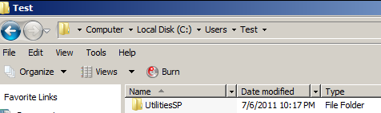  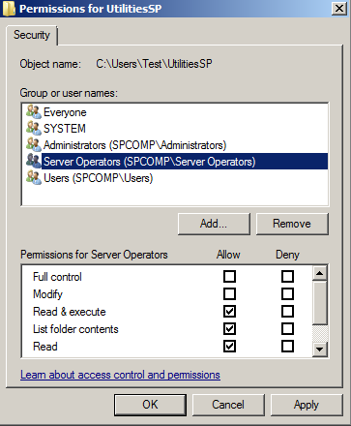  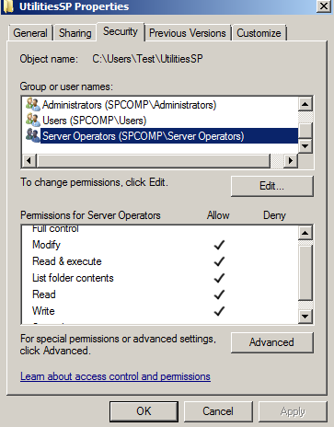 | 1. Folder created called UtilitiesSP under a folder that was created called Test under the c: Users folder as shown to the left.  2. The following users have permission to access and use this folder:  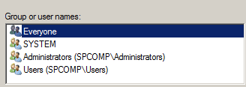  3. The Everyone and Users folders have the least amount of priveledges: read, read and execute, list folders contents. The System and Administrators have full access minus special permissions.  5. A screen shot of the server operators dialog box.  6. By default they have the read and execute, list folder contents and read permissions as did the Everyone and Users groups.  7. Server Operators now have access to Modify.

# | Page | Chapter/Activity | Status | Description
34 | 190 | 5-3 |  | Removing Inherited Permissions

Screen Shot(s) | Documentation
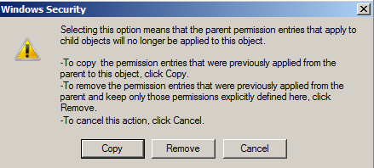  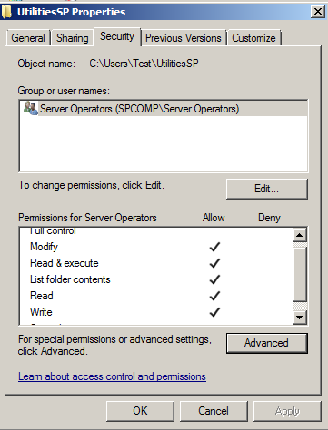 | 6. Getting ready to remove the windows inherited permissions.  7. I now only have the server operator’s choice for groups.

# | Page | Chapter/Activity | Status | Description
35 | 192 | 5-4 |  | Configuring Special Permissions

Screen Shot(s) | Documentation
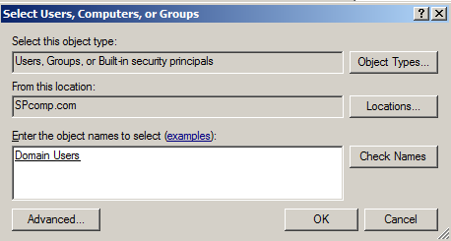  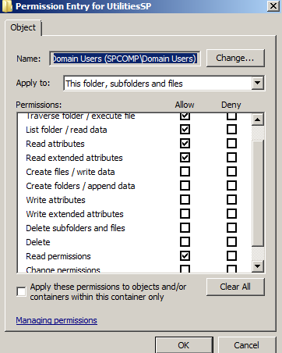  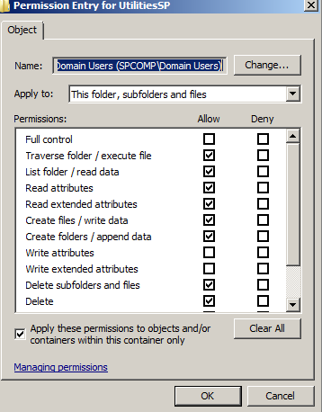 | 9. Okaying the Domain Users Group.  14. Permissions that are set by default are: Traverse folder / executable file, list folder / read data, read attributes, read permissions  Changes Made to the Permissions.

# | Page | Chapter/Activity | Status | Description
36 | 195 | 5-5 |  | Auditing a Folder

Screen Shot(s) | Documentation
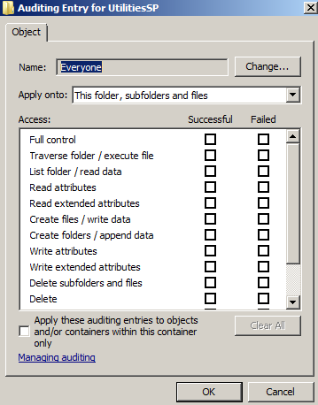  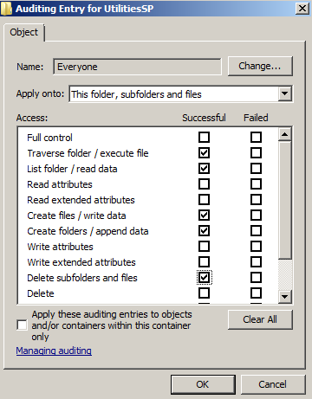 | 10. Everyone has been selected.  12. Access set as successful for the following (to the left)…

# | Page | Chapter/Activity | Status | Description
37 | 197 | 5-6 |  | Enabling Sharing a Folder

Screen Shot(s) | Documentation
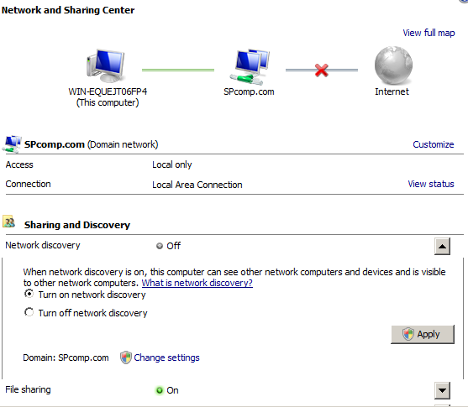 | 3. I have turned on the network discovery and applied.  For some odd reason, network sharing would not turn on no matter how many times I clicked and applied. All others worked though.

# | Page | Chapter/Activity | Status | Description
38 | 200 | 5-7 |  | Configuring a Shared Folder

Screen Shot(s) | Documentation
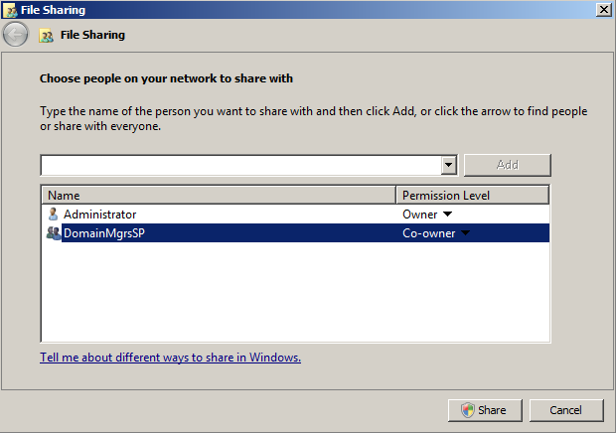  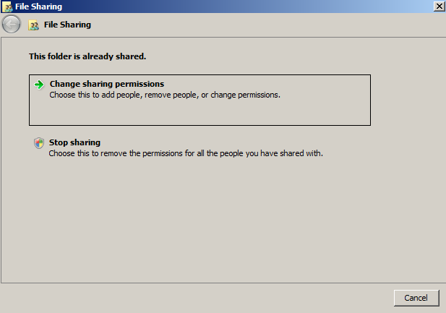  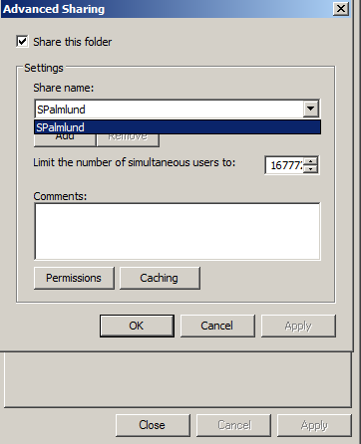  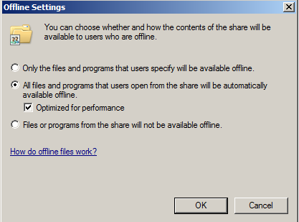 | 7. File is now set as Co-Owner.  12. I can now change permissions and stop sharing from the File Sharing Dialog box.  15. To Change the name of the share folder, I simply rename the folder itself.  To set the limit of users who can access at this time, I change the Limit number in the drop box to the left.  18. All files and programs that users open from the share will be automatically available offline with optimized performance are now checked.

# | Page | Chapter/Activity | Status | Description
39 | 202 | 5-8 |  | Publishing a Shared Folder

Screen Shot(s) | Documentation
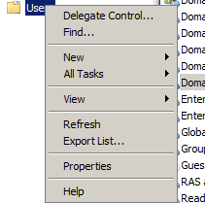  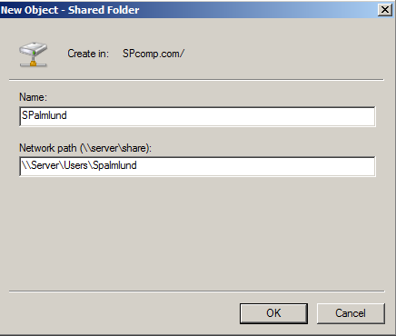  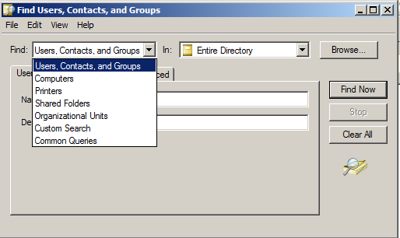  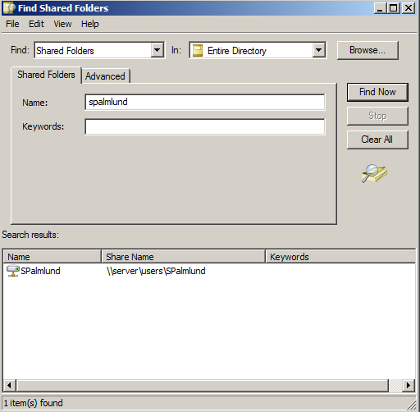 | 3. I can add a new printer or a new shared folder.  5. Here is my created shared folder.  8. You can search for computers, printers, shared folders, organizational units, custom search or common queries.  10. Here is my folder that was searched for.

# | Page | Chapter/Activity | Status | Description
40 | 204 | 5-9 |  | Troubleshooting Permissions

Screen Shot(s) | Documentation
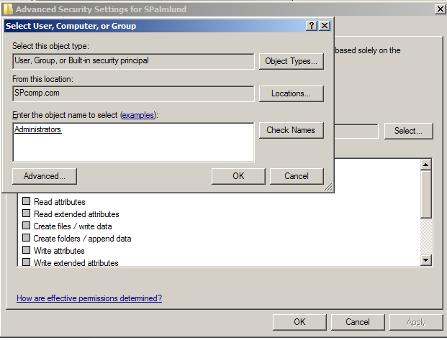  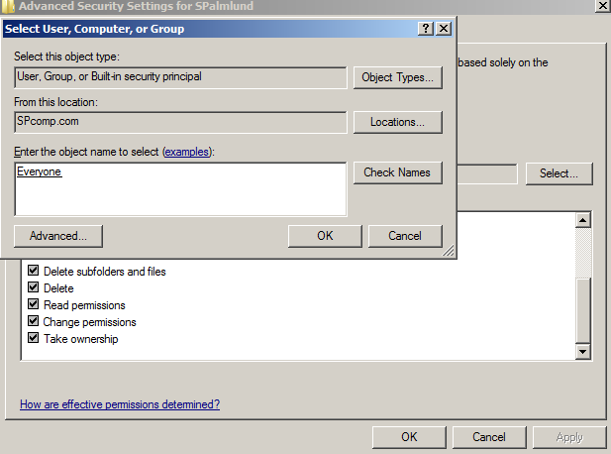 | 6. Screen shot of work completed from #1-#6  #8. The Effective Permissions for the everyone group are all disabled meaning that they do not have access to public information as does the administrators folders.

# | Page | Chapter/Activity | Status | Description
41 | 208 | 5-10 |  | Creating a Namespace Root

Screen Shot(s) | Documentation
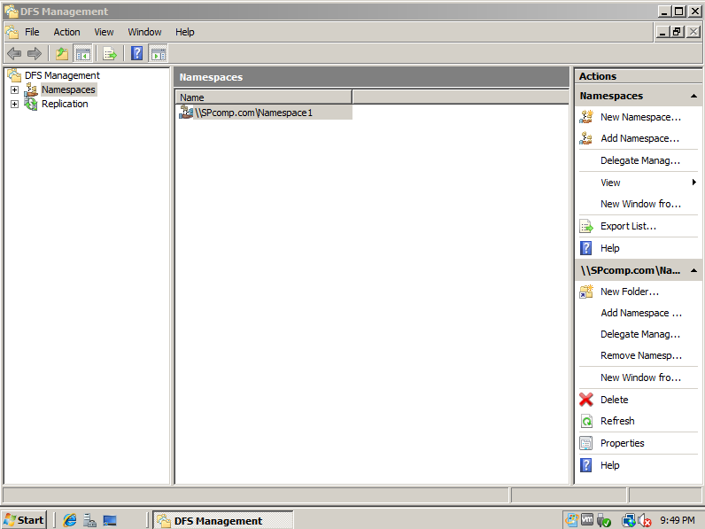 | Creation of a Namespace Root – I called it Namespace1.

# | Page | Chapter/Activity | Status | Description
42 | 210 | 5-11 |  | Auditing a Folder and Folder Target in DFS

Screen Shot(s) | Documentation
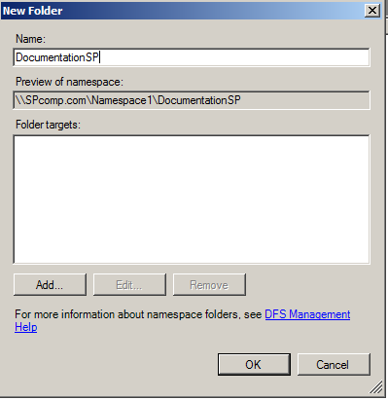  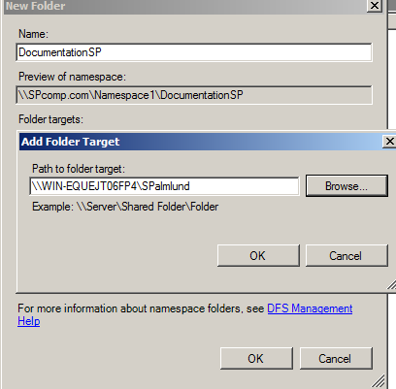 | 4. Showing the creation of a folder under my new Namespace. Folder is called DocumentationSP  8. Hooking my shared folder to my new namespace.

# | Page | Chapter/Activity | Status | Description
43 | 213 | 5-12 |  | Configuring Disk Quotas

Screen Shot(s) | Documentation
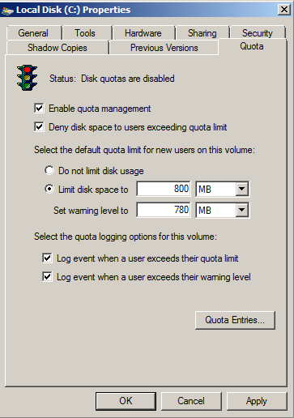  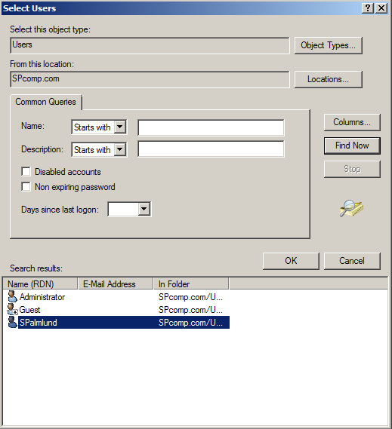  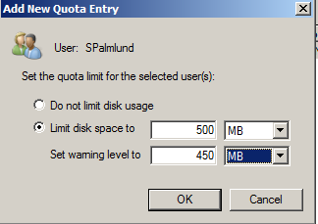 | Steps 1-9 show the denying of the disk space, the limit disk space and warning level, and the log events have been added.  12. Adding folder for quota enteries.  14. Adding the limit of disc space – quotas were then turned off so as not to interfere with future labs.

