Memory Lab

Tuesday, June 09, 2009

11:12 AM

Memory Lab

Name: Shannon Palmlund

Scenario:

You have been requested by either your school or your employer to secure bids for completing a memory and hard drive upgrade for a Fujitsu T1010 system.

Information on the Fujitsu TPC:

1. **Go to the following web address:**

[**http://support.fujitsupc.com/CS/Portal/support.do?msrch=serial**](http://support.fujitsupc.com/CS/Portal/support.do?msrch=serial)

**Use the following serial number:** R8904701

Then select “GO” to find the information on the given serial number.

Scroll down until you find the processor description and list below.

[Intel® Core™ 2 Duo Processor](http://syndication.intel.com/DistributeModule.aspx?ppc_cid=IIP_02106070601&cc=US) P8400 (2.26 GHz, 3MB L2 cache, 1066 MHz FSB)

Pasted from <<http://solutions.us.fujitsu.com/www/content/products/notebooks/tech_specs/t1010_ts.shtml>>

What is the delivered memory?

DDR3-1066 MHz SDRAM dual-channel memory module.

Two DIMM slots; upgradeable to 4 GB of total memory (2 GB x 2)

Pasted from <<http://solutions.us.fujitsu.com/www/content/products/notebooks/tech_specs/t1010_ts.shtml>>

Describe the delivered hard drive?

160 GB, 120 GB, 5400 rpm; Serial-ATA; shock-mounted; Shock Sensor Utility locks the hard drive when detecting sudden impact, freefall, or vibration (may have to install this application separately)

Pasted from <<http://solutions.us.fujitsu.com/www/content/products/notebooks/tech_specs/t1010_ts.shtml>>

1. Go to the Intel site, [www.intel.com](http://www.intel.com), search for the “P8400” processor. Select the first link “Intel Core 2 Duo Processor P8400” based upon the clock speed, locate the processor found on the specs, what is the clock speed?

[Intel® Core™ 2 Duo Processor](http://syndication.intel.com/DistributeModule.aspx?ppc_cid=IIP_02106070601&cc=US) P8400 (**2.26 GHz**, 3MB L2 cache, 1066 MHz FSB)

1. Go to [www.kingston.com](http://www.kingston.com) and complete a memory upgrade on the Fujitsu notebook.You are going to upgrade your memory from the existing \_2\_GB (see spec sheet) of ram to 4GB of ram. Create a screen clipping of the appropriate RAM to upgrade the system to 4GB. Place screen clipping below:

DDR3-1066 MHz SDRAM dual-channel memory module.

Two DIMM slots; upgradeable to 4 GB of total memory (2 GB x 2)

Pasted from <<http://solutions.us.fujitsu.com/www/content/products/notebooks/tech_specs/t1010_ts.shtml>>

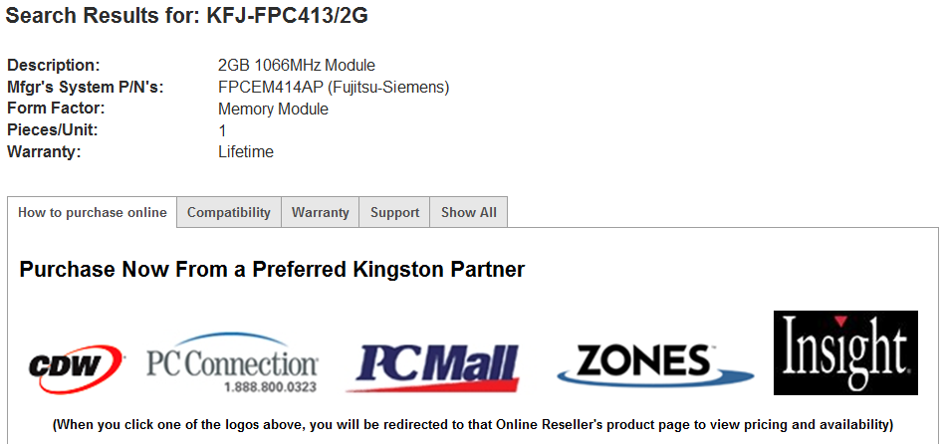

**Purchase Now From Kingston**

|  |  |  |  |
| --- | --- | --- | --- |
| **Availability** | **Price** | **Qty** |  |
| In Stock | **$108.00** |  | C:\0FAB9705\E0DAEF4E-DB9F-41D8-BF99-DC998FFF95D7_files\image002.gif |

Pasted from <<http://www.ec.kingston.com/ecom/configurator_new/partsinfo.asp?root=us&LinkBack=http://www.kingston.com&ktcpartno=KFJ-FPC413/2G>>

1. Find another site that has the same memory for sale and place the screen clipping below. This will require significant internet searching:
2. 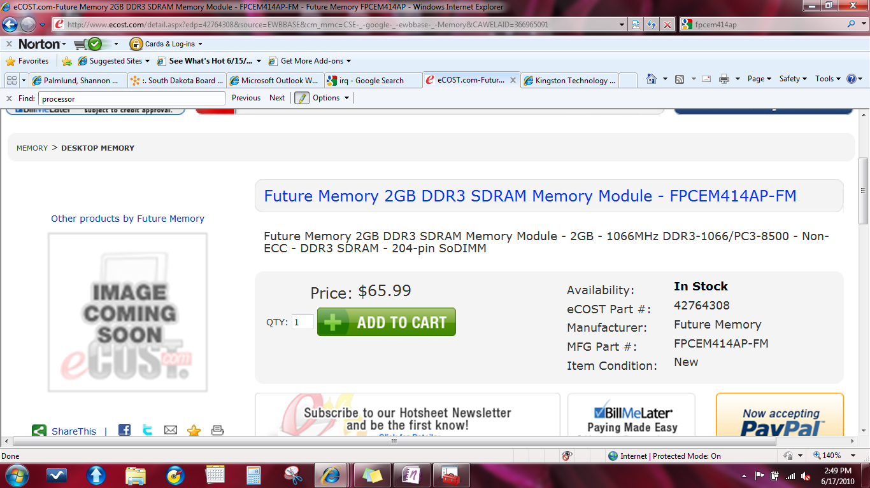

1. Locate the hard drive specs and continue to [www.cdw.com](http://www.cdw.com) to find the price of an 200 GB (or larger) 2.5 sata hard drive. What is the price? 61.99

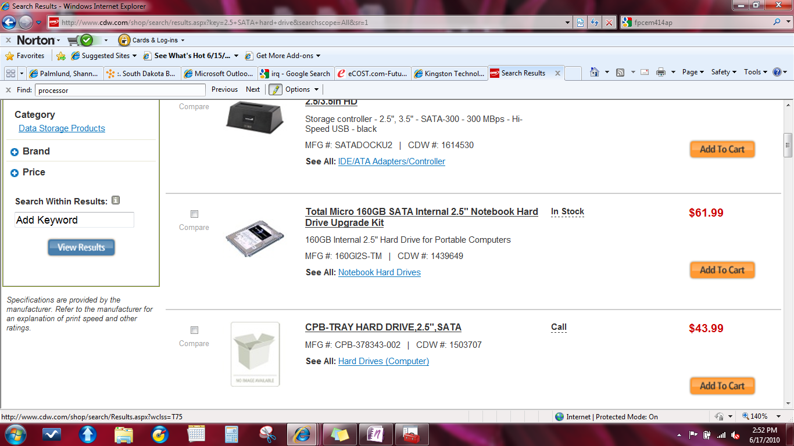

Go to a competing site and find another price. What is the URL and what is the price?

