*Site Purpose/Content:*

I have chosen to evaluate a website that I was recently introduced to by the South Dakota Department of Education called, *Write to Learn*. All public schools are now required to administer this annual writing assessment as directed by the South Dakota Department of Education. *Write to Learn (more specifically)* is an online formative assessment tool created by Pearson (a company well-known for creating textbooks) in response to previous writing assessment attempts and failures.

Basically, a pilot program of English teachers was created last year in order to better the writing assessment that was originally conducted by the state. Teachers felt the original assessment did little to actually measure what they wanted to measure in student writing. Pearson took input from teachers across several states ultimately creating, *Write to Learn*.

Students in grades 5, 7, & 10 use this online literacy program which provides immediate feedback on essay and summary writing activities. With the feedback provided by the online program (grammar, spelling, word count, minutes on task, number of attempts, and the six + one writing traits: idea, organization, convention, sentence fluency, word choice, and voice) teachers are able to better shape instruction and promote student achievement, and the state is then able to track student progress.

Several prompts (journaling ideas) have been built in to the program. These prompts were utilized by a testing group of students from around the world. Once evaluated by Pearson’s professional editors, the prompts are ranked by grade level, and rubrics are created within the program. When our students write on this same prompt and then hit *Get Feedback* on their essays, their essay is compared to the rubric in the system and they instantaneously receive feedback on the information I mentioned above. This is very beneficial because what would normally take me days to correct is now ready for the student to edit and revise in seconds. Teachers also have the freedom to add their own prompts, but scoring will not be as in-depth because the comparison rubric created by the professional editors is not available.

*Web Design/URL*

Availability: Although the website is created for English writing testing, I believe it is available for those who wish to purchase licenses (the state purchases licenses for all students in grades 5, 7, and 10 this year) and I know school discounts are available to all South Dakota affiliated schools this year.

User Access: Students are able to access the site so long as they have internet connectivity. It can be accessed anywhere, however, which could be an issue if someone else felt like taking the time to do the work for the student! You are able to limit the number of tries the student can use for submission, but I have found this to be more of a hassle. Adding time constraints to the program would be very beneficial. I could then set it to be accessed during school hours only solving the above dilemma.

Administrator/Teacher Access: I have found this to be somewhat of a downfall. The state gave username and password information to the school administrator (in this case our principle); however, the school administrators were not required to participate in training. One teacher from each district was required to attend a *Write to Learn* training, and we were then told to go back and train the other teachers that would need to access the site.

Once I got back from training, I found that I had to take over for my administrator because he did not have the computer skills or knowledge needed in order to work the program. I can see this being a problem in other schools as well. The school technology coordinator should have been in charge or the teacher who was trained should have been given the administrative privileges.

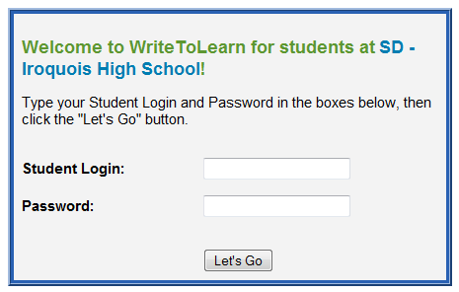Once I received the forwarded emails from my administrator with password information, I realized there was an even larger issue. There were for entities I was going to have to set up: elementary, middle school, high school and colony. This was poor planning on the part of Pearson. Instead of being in charge of one overall district, Pearson requires each school within the district to be its own entity.

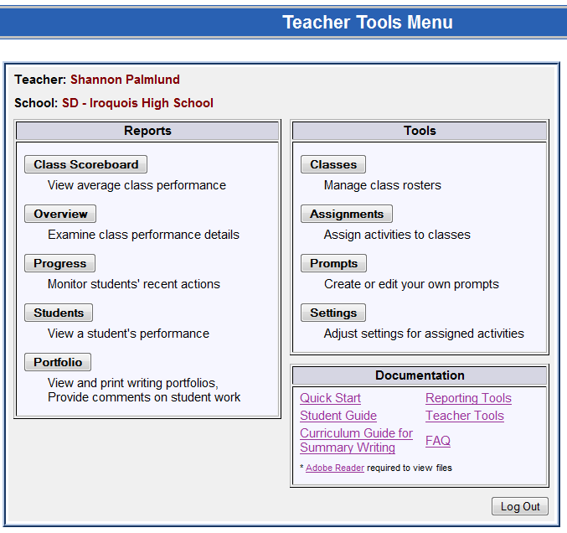Example: We have twelve websites: four for the administrator, four for each teacher/school and four for each school/student (we are one of the smallest schools in South Dakota so my heart goes out to those tech coordinators that got stuck creating rosters, teacher accounts, etc. for each school!). In order for a high school student at Iroquois to log in to the *Write to Learn* site, he/she must go to: [www.pearsonkt.com/writetolearn/sd/0200301](http://www.pearsonkt.com/writetolearn/sd/0200301). Now, the last seven-digit code changes for each entity/school within a district. As stated previously, we have four parts to our school so we have four seven digit codes and three groups: administrators, teachers, and students – leading to our twelve websites!

Organization/Navigation/Graphic Interface (Teacher/Student): The site is well-organized. As a teacher, I am able to see a dashboard called the *Teacher Tools Menu* when I log in. It allows me access to *Reports* to all classes that I have assigned materials, *Tools* for assigning materials, and *Documentation* in case I get in to trouble along the way. As you can see in the graphic, each button gives me a brief explanation.

So far, I have found the Overview button to be most beneficial when viewing student reports. Once clicked, I choose: 1) the class that I wish to view, and 2) the class activity (I previously assigned this activity/prompt to the class and the student(s) have submitted their writing). Below is a screen shot of what an example overview might look like (I have removed the student’s name for confidentiality purposes).

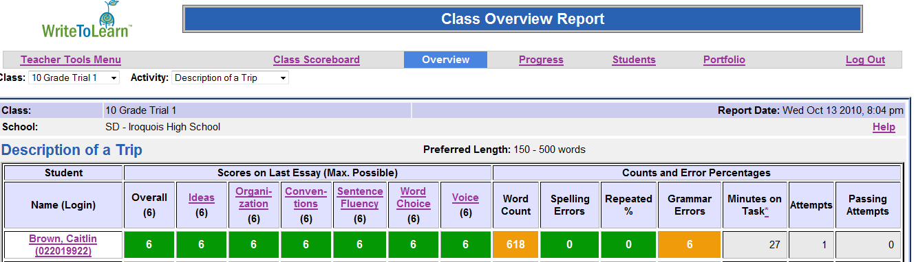The only problem I have noticed with this option is that once I have set the rubric for the 6+1 writing traits (if I choose to change them from what the Editors have set as satisfactory) the passing attempts will not adjust correctly if they have submitted prior to my reset. Otherwise, it has been extremely helpful!

1

2

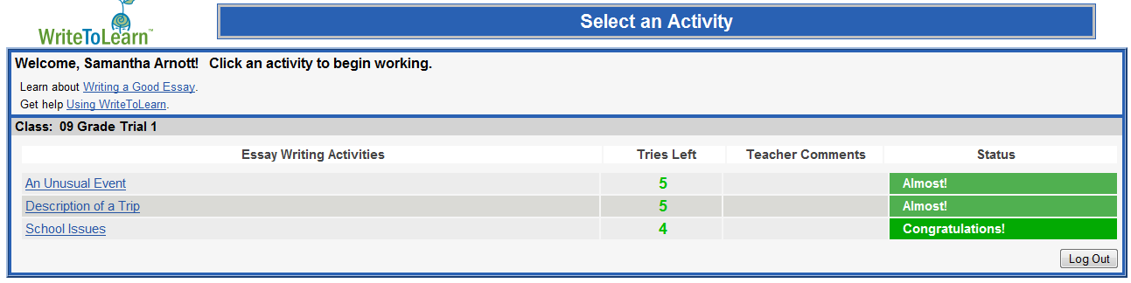Navigation for the student is even easier. Once logged in, they are able to see every prompt that has been assigned to them. They can also see if they have a passing score on the prompt and whether or not they have any tries left. As long as my students have met my passing requirements, they don’t have to submit all 6 tries (which is the standard default of the program). I do require them to submit at least 2 tries since they are required to recheck their spelling and grammar.

I am able to comment on each writing activity, which is where I often give them their grade and explain how I reached the grade (no comments are viewable in the above screen shot, however.

One neat feature of the program is its ability to process what the students are writing. If they write less than 50 words, it will not accept their input. If they are off topic, it is able to apply what it has stored in its database for positive student responses and immediately return feedback addressing this issue. If cussing is introduced in the essay, it will inform the writer they need to stay on topic as well.

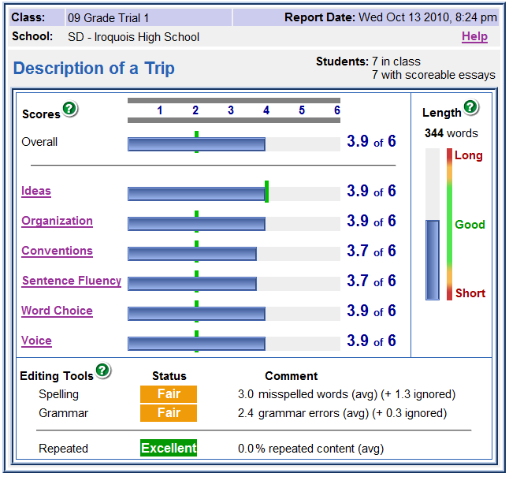At this time, we are working on one of the 6+1 writing traits each week. Students have finished Idea and Organization. Pearson editors generally have these set at a 4 out of 6 (as you can see in the next graphic). I drop the ones we haven’t gone over down to a 2, and students can see whether or not they are passing every time they hit *Get Feedback.* To the right is a screen shot of my overall class scoreboard. Each student is able to see the same thing, just not the class average as I am showing you here.

Example: In the essay prompt, *Description of a Trip*, my ninth graders exceeded all 6+1 writing traits. We were working on *Idea* this particular week so you will notice that the green bar is set at 4. Students are also able to see their length and are able to fix spelling, grammar, and repeated words by clicking on their status – we needed a little more work in this area!

Interactivity/Usability of the site: The site is highly interactive. In the graphic above, you are able to see that students can click on any of the 6+1 traits or other buttons/hyperlinks. Once clicked, students receive more information in regards to the button they have clicked. When students click on spelling or grammar, they see their text underlined in red or green much like Microsoft Word, allowing them to make corrections.

Students have access to accommodating features such as: a text-to-speech reader, dictionary, thesaurus, and a Spanish translator. Although the Spanish translator is helpful, we do have a colony which speaks German. Adding a German translator to the program would be beneficial to our District as well. The only other complaint that I have about usability is that students are unable to see their word count until they hit *Get Feedback*.

Support: When I first began working with the program, my Administrator accidentally deleted an entire class roster. This prompted Pearson to lock the site so we were unable to access it. I contacted the state, but they informed me they couldn’t help with this type of problem. I then had to contact Pearson directly. Although it was quite painless, it did take three tries and a great deal of time on the phone before it was fixed. In the future, it would be helpful if I could contact our state directly.

Instructional Design: Because the site has been created based on outcomes of a pilot program, I believe it fits the Dick and Carey Model closely. The site addresses instruction as an entire system, focusing on the interrelationship between context, content, learning and instruction as does the Dick and Carey Model. With this model, components are executed repeatedly and in parallel rather than linearly which is relevant since Pearson will continue to create prompts indefinitely that are tested and reviewed by their editors all while the program is available to schools.

Theory: From what I can tell, the Pearson Company created *Write to Learn* based on the Behaviorist Learning Theory. It focuses on the learner’s behavior in response to consequences more so than environmental factors. As mentioned in our content section from our readings, “Behaviorism advocates strictly sequenced instructional events to foster learning, with an emphasis on feedback and revision, particularly correction of erroneous trials and reinforcement of correct behaviors”. Students are given several tries to fix mistakes made within the program. Each time they submit their work, they are given instant feedback that allows them to reassess their work and go on from there.

In addition to the Behaviorist Theory, I can see how the Situated Learning and Associative Learning Theories would also be valid. It mentions in our content that “1) Learning can be promoted when new information can be integrated into existing knowledge of the learner, 2) more learning can occur where information is received concurrently in two modalities, e.g., vision and audition or vision and touch, than where received in only one modality, and 2) the more concrete the things to be associated, the more readily they are learned and remembered.” Each of these applies directly to the functionality of the program. Students are able to use existing knowledge by applying prompts to their own lives and they are able to work with vision, audio and touch within the program.

*Conclusion:*

As stated previously, there are a few glitches that need to be improved upon. Teachers need to be able to moderate user access to make sure the student is in charge of his/her own learning. Site set-up should be located within one main site for each district instead of each school within the district having its own web address. The user tools could be improved upon allowing other languages for translation, and a word count prior to submission would be helpful. Finally, site support should be directed to one entity instead of both the state and Pearson.

Overall, I would give the program 8 out of 10. It has given me the freedom to teach writing instead of correct it! What used to take me days to correct is now instantaneously corrected allowing my students a quick response to their writing. However, I do feel it is still vital for the teacher to read through what the students are writing and grade accordingly to make sure they are on the right track!