**[Contact Info](http://www.rememberthemilk.com/home/spalmlund/7348702/46502157)**

Today, February 08, 2009, 7 minutes ago | shannon

Due: Mon 9 Feb 09

Priority: none

Time estimate: none

Tags: none

Location: none

Postponed: never

List: Inbox

Contact Info:

Student 1: Dennis Smith Software: Microsoft Excel Phone: 605-854-3050 Student 2: Sheila Smith Software: Microsoft Excel/Web editing Phone: 605-854-3050

Updated: Sun 8 Feb 09 at 1:37PM

[**Meet with Mentees**](http://www.rememberthemilk.com/home/spalmlund/7348703/46501020)

Today, February 08, 2009, 6 minutes ago | shannon

Due: Wed 11 Feb 09

Priority: 1

Time estimate: 1/2 hour

Tags: none

Location: none

Postponed: never

List: Personal

Meet with Mentees

1) Where to they want to be when they have completed the Project. 2) What do they hope to accomplish for a project? 3) What times will work best for meetings. 4) How often can we meet.

Updated: Sun 8 Feb 09 at 1:18PM

[**Day 5: Debrief**](http://www.rememberthemilk.com/home/spalmlund/7348703/46501955)

Today, February 08, 2009, 11 minutes ago | shannon

Due: Mon 16 Mar 09

Priority: none

Time estimate: 2 Hours

Tags: none

Location: none

Postponed: never

List: Personal

Debrief

1) Begin by having student complete an evaluation. * Did they learn what they intended to learn? * How confident do they feel in themselves? * How do they feel about your teaching/learning/timeline, etc. 2) Have students present their final projects to you.

Updated: Sun 8 Feb 09 at 1:33PM

[**Day 4: Observe**](http://www.rememberthemilk.com/home/spalmlund/7348703/46501745)

Today, February 08, 2009, 14 minutes ago | shannon

Due: Mon 9 Mar 09

Priority: none

Time estimate: 2 Hours

Tags: none

Location: none

Postponed: never

List: Personal

Observe

1) Begin by watching students teach something that you have assigned them to teach to their classmate. * Are they able to do with little or no help? * Are they able to address the menus with their proper names? * Are they able to answer questions of their student? 2) Continue Teachings...Assign their final Project.

Updated: Sun 8 Feb 09 at 1:30PM

[**Day 3: Confer**](http://www.rememberthemilk.com/home/spalmlund/7348703/46501593)

Today, February 08, 2009, 16 minutes ago | shannon

Due: Mon 2 Mar 09

Priority: none

Time estimate: 2 Hours

Tags: none

Location: none

Postponed: never

List: Personal

Confer

1) Begin by asking students what they have learned over the week. * Have they played around with the program. * Have they completed the homework project assigned to them. 2) ReAsses: What do they hope to accomplish and Where do they want to be when finished - Has this changed? 3) Continue with teachings.

Updated: Sun 8 Feb 09 at 1:28PM

[**Day 2: Co-Teach**](http://www.rememberthemilk.com/home/spalmlund/7348703/46501442)

Today, February 08, 2009, 19 minutes ago | shannon

Due: Mon 23 Feb 09

Priority: none

Time estimate: 2 Hours

Tags: none

Location: none

Postponed: never

List: Personal

1) In order to Co-Teach. Have the two students help each other through tasks.

* Once tasks are completed for the day, Quiz the student and have him/her tell you how to do something they have accomplished for the day.

Updated: Sun 8 Feb 09 at 1:25PM

[**Day 1: Observations**](http://www.rememberthemilk.com/home/spalmlund/7348703/46501210)

Today, February 08, 2009, 22 minutes ago | shannon

Due: Mon 16 Feb 09

Priority: none

Time estimate: 1/2 Hour for Each

Tags: none

Location: none

Postponed: never

List: Personal

1) Have student show you how to open the software.

* Observe: are they able to open software? * Can they navigate the desktop/ribbons and chunks? 2) Ask students to do a couple of things relating to navigating the software. * Are they able to do what you ask?

Updated: Sun 8 Feb 09 at 1:21PM

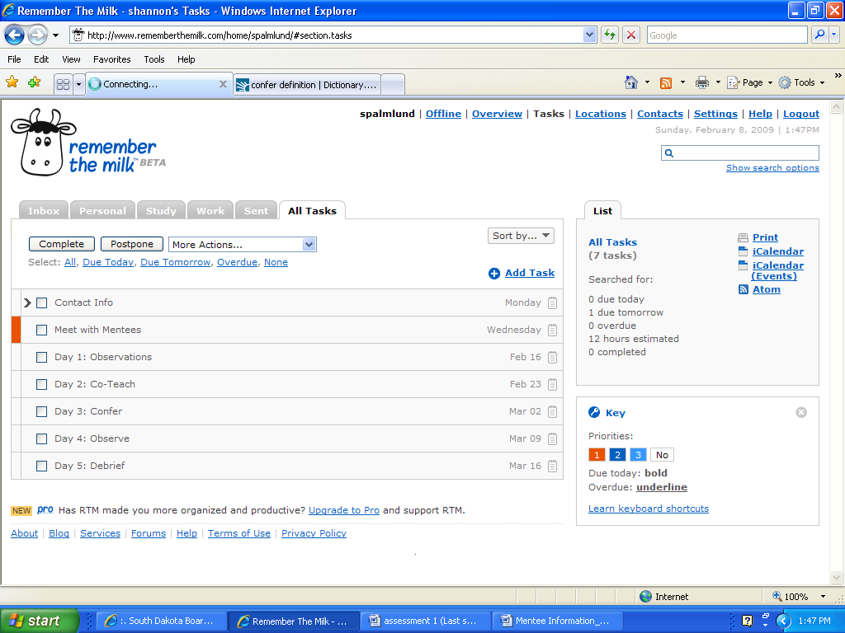[Show all items](http://www.rememberthemilk.com/atom/spalmlund/7348707/?tok=eJwNzUsKwzAMRdEVGayPJXs5eokEAbcU0u6-md7BuUYVlhl0zOBgE1NbGGBV6h6eR3UilVhjoFhMgIoThAkp4nZ-Yr-27322fd3f5qLTuzfilcmE5EmSazIfLBo94hnWE9wcgCxy7hiVo3Q8rmMV*4k-6UYrhQ)